**oTc**

John Katumo, Daniel Ortiz, Nathan Clayton

**Online Trading Cards**

Online Trading Cards (oTc) is a website that creates and distributes virtual trading cards of your favorite baseball players. When a collector wants to start building their collection, they purchase a ten pack of virtual cards and they receive 10 virtual cards to put in their collections. Each card will have the player’s latest stats. Unlike physical trading cards, our player stats are updated every day so your card never goes out of date. It’s bringing a childhood pastime into the twenty first century.

**End Users**

The end users of our service will be sports fans and sports card collectors who want to create a virtual card collection to share and trade with friends.

**Data Source**

For our data source, we have decided to use the website [www.mySportsFeed.com](http://www.mySportsFeed.com). This website provides an API (Application Programming Interface) that will be capable of retrieving the player and team data that is necessary for creating sports trading cards. It also has stats updated every day.

**Business Rules**

* A collector may have many collections but a collection belongs to only one collector.
* A collection may have many cards, but a single card belongs in only one collection.
* Each card represents a single player, but a player may be represented on many cards.
* A team may include one or more players and players are only allowed to play for one team.
* For every collector, we must store their name, age, and a valid e-mail address.
* A collector must be at least 13 years of age.
* Every collection must contain a name, description, and number of cards (no less than zero) in the collection.
* Every card must contain its creation date, name, and description.
* The names and descriptions for cards and collections are defined by the collector after creation.
* We must store the name, city and abbreviation for every team.
* Team abbreviations must be 3 characters in length.
* Every player must have a name, position, jersey number, age, height, weight and if the player is a rookie.
* A player’s age, jersey number, height and weight cannot be negative.

**ER Diagram**

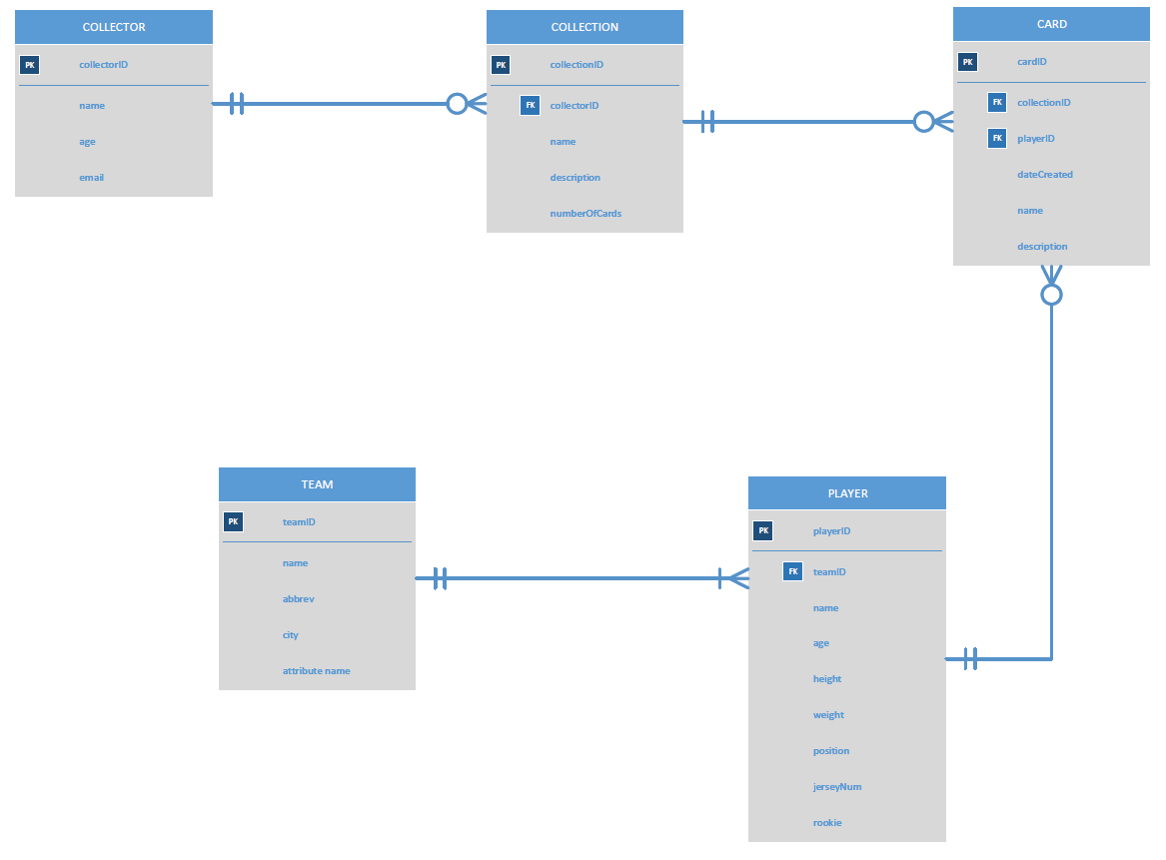

**Project Plan**

1. Group Name – oTc (Online Trading Cards)
2. Group Members – John Katumo, Daniel Ortiz, Nathan Clayton
3. Roles
   1. John Katumo – Group Leader, Editor, Proofreader, Detail-Oriented verifier
   2. Daniel Ortiz – Version Controller, Graphic Designer
   3. Nathan Clayton – Data Collector, Integrator
4. Group Norms
   1. Communication – Within our group, primary communication will be via text messaging. Response within 2 hours is acceptable for text messaging communication during the work week. On weekends, there is no expected communication from any member. We value a work/life balance. If any documents need to be send between group members through email, only those who are working with the information should be carbon copied. Otherwise, we would like to refrain from extraneous messages being sent.
   2. Group Decisions – All decisions pertaining to a certain role or function are handled by the person placed in that role or function. Any matters that overlap the functions of multiple group members will be settled between those involved group members with any stalemate disputes being decided by the Group Leader.
   3. Work Progress – We will be using a Lean-Agile working methodology, we will set up to ten milestones as a team with given expected completion dates for each milestone. Each milestone will be expected to be completed and given to Group Leader by the due date. Once a milestone is completed, we immediately move onto the next milestone until we are finished with the project.
   4. Attitude – A positive attitude is all it takes to succeed. That’s all we ask of each other.